**Question 01- Airplane Seating Assignment (50 points)**

Analyzing problem:

Step 1: I created a method public static void SeatInitialize(char [][]arr) that will initialize entire table with stars (*).

Step 2: I needed a method that return index of seat (column). I created

public static int getColumnIndex(char w); for example, if user enter seat D it will return 3 for column index.

Step 3: I need a function to check if the seat is taken or empty.

public static boolean OccupiedSeats(char [][] arr, int row, char column); this function takes an array, row, and column as arguments. It will return true if seat is not taken. Otherwise return false.

Step 4: I need a print method that will print the table and seat assignments. I created

public static void SetAssignments(char [][] arr); takes an array as an argument. I created tow one dimensional arrays inside the function. The char array prints the seats position from A to F. String array prints the rows. The arr print 2d array length 13x6.

Step 5: My goal is to make main method clean as possible. I created a function that will ask user to enter rows and column; the program will check for valid inputs. Then I check seat calling OccupiedSeats(arr, row, column); if it returns false I ask user again to enter a different row and column. If not the case, I just reserve a seat at the given row and column. I named this function public static void reduceCopyingPastingCode(char [][] arr, int Start_of_row, int End_of_row); Each plane class starts at different row and end at different row. For example, first class 1 to 2, business class 3 to 7, and economy class 8 to 13. The code will be same for each classes. I just made the function to take two rows ( start and end). It will reduce redundant code.

Step 6: I made another method to assign seats. I named it I called it

public static void AssignSeat(char [][]arr, char FlightClass) ; this method takes flight class ( F,B, E) from user. I called reduceCopyingPastingCode(char [][] arr, int Start_of_row, int End_of_row); for each cases. Example :

case 'E' : 'e':

reduceCopyingPastingCode(char [][] arr, 8, 13 ); so on ..

Note: Read comments in code for more detailed explanation.

Testing program:

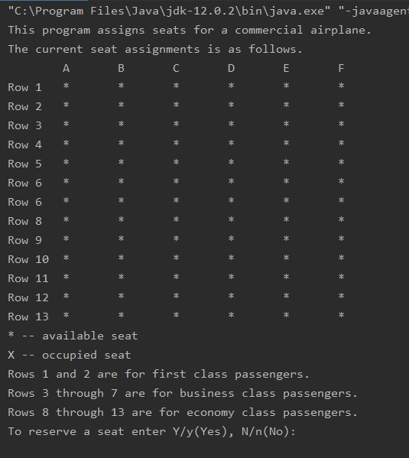

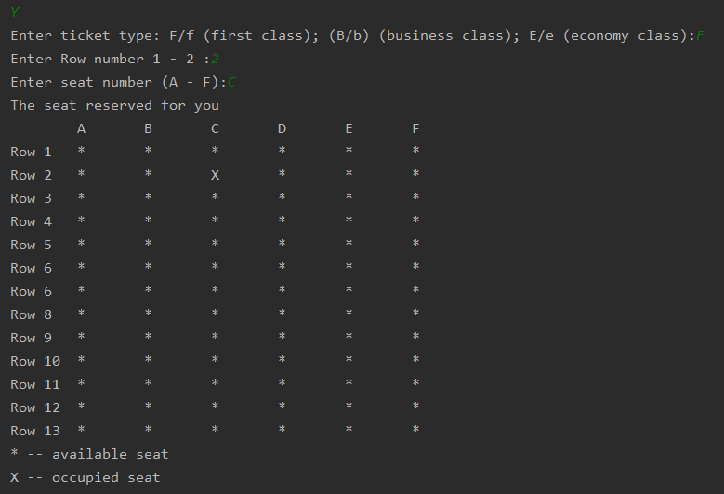

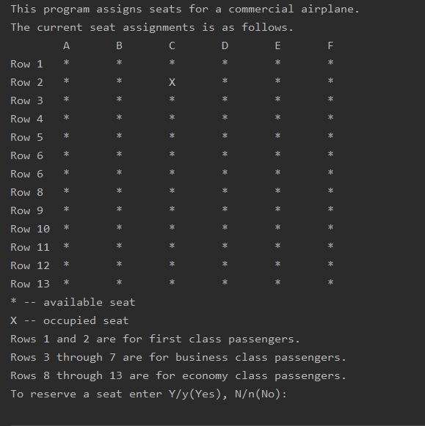

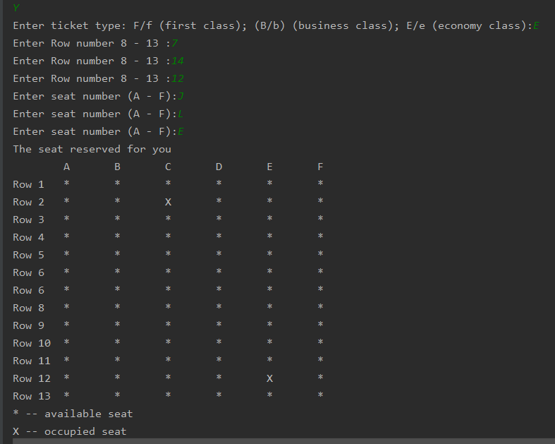

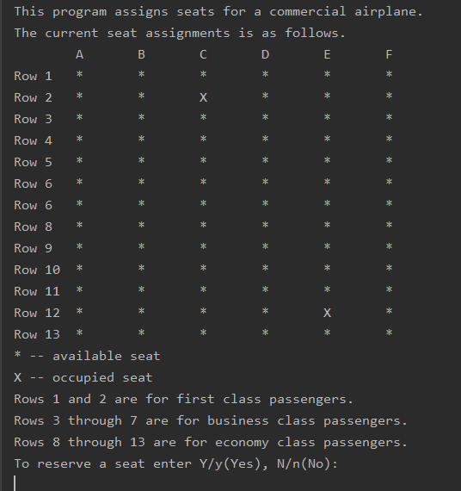

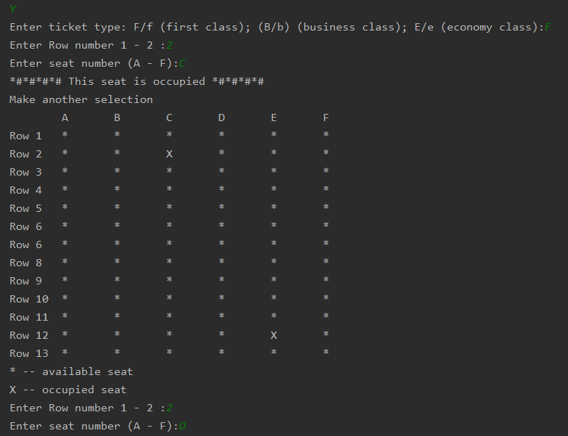

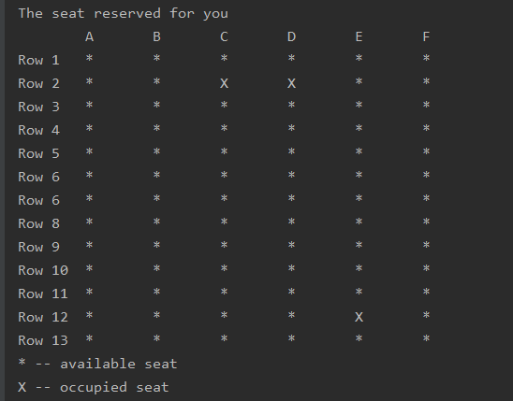

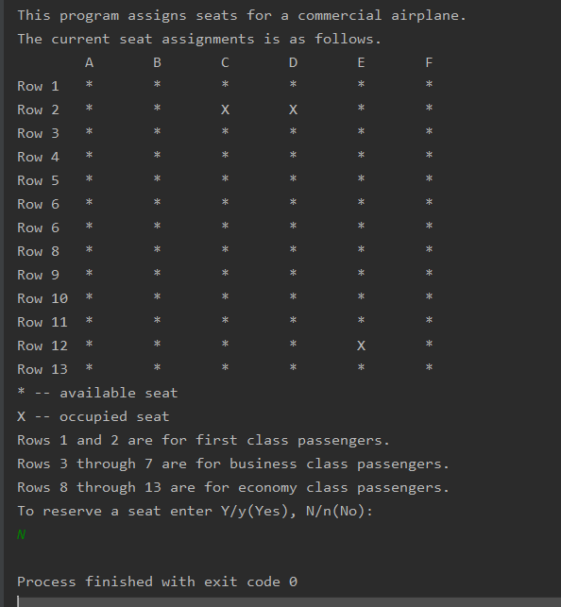

**Question 02 - *Morse Code* (20 points)**

Analyzing problem:

This problem is straight forward. I stored the Morse code and corresponding characters in 2d array. Left column contain the letter and right column contain Morse code.

To Change English to Morse Code:

Step 1: I need a search method that compares characters from string and character from table. And return the Morse code from right column of table.

Step 2: I need another method that return a string of Morse code. I will pass a string from user and 2d array. Then capitalize the string. The latter in table are capitalized so have to make string capital for accurate result.

I need a for loop to iterate through the string. The length is from 0 to string.length()

1) check, if any character is a space, then add **three spaces** to string.

2) Otherwise, call the search method and add the search value in string with one space.

To Change Morse Code to English:

Step 1: I need a search method that takes a string and 2d array. It will compare string and object from 2d array (Morse code). If they equals then the method return corresponding letter as a string.

Step2: I need another method that decode the Morse code and return the normal text as a string. It takes string from user (Morse code) and 2d array. Inside the function I have to split the Morse code with three spaces. Morse code separate words with three spaces. After splitting we will have the words in array of strings. For example:

S= **"- --- -... . --- -. -. --- - - --- -... ."**

String [] words = {**- ---**, **-… .** , **--- -.** , **-. --- -** , **- ---**, **-… .** };

After that we have to do following:

Each word in Morse code separated by one space. We have to split the string at each index and convert each Mors code to its corresponding letter. Add a space when its end of the word.

Note: See my code for detailed explanation.

Testing program:

Test 1: 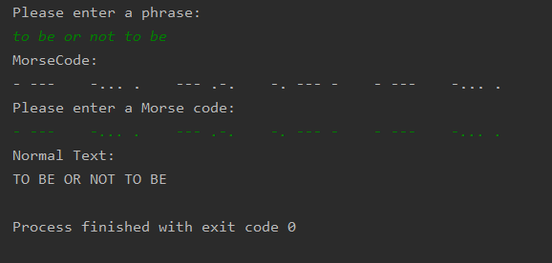

Test 2:

